When you are at work on Monday morning you do not have an idea which work will be coming first and which are the ones that can have less priority.
Time management is quite important when it comes to the work which you genuinely love to do. Effective task prioritization helps a person to be better at their work and provide some good results.
Getting things done is the first priority but of course there must be a control on the things that you are going to approach first. This will help the person to be ready with the work that they want to do.
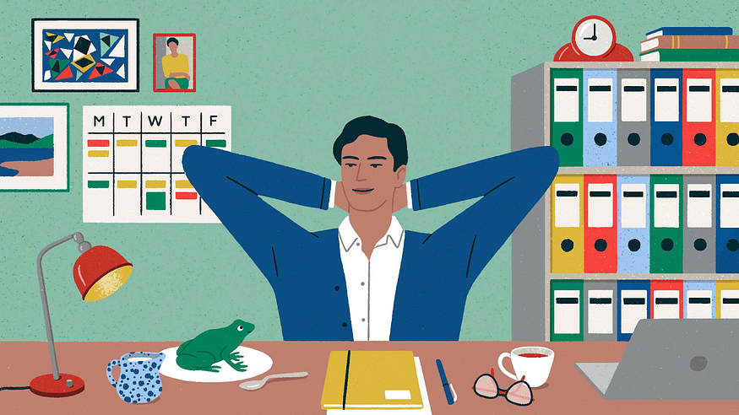
Credit: MailChimp
Here are some Prioritization methods that can be used to manage the workload at the office and solve the problems of handling complex work.
Daily task planning is important
Having the task that you have planned before helps a lot. When you know that there is plenty of work that you have to do on Monday morning. It is better to engage with the work on Sunday morning and schedule the work.
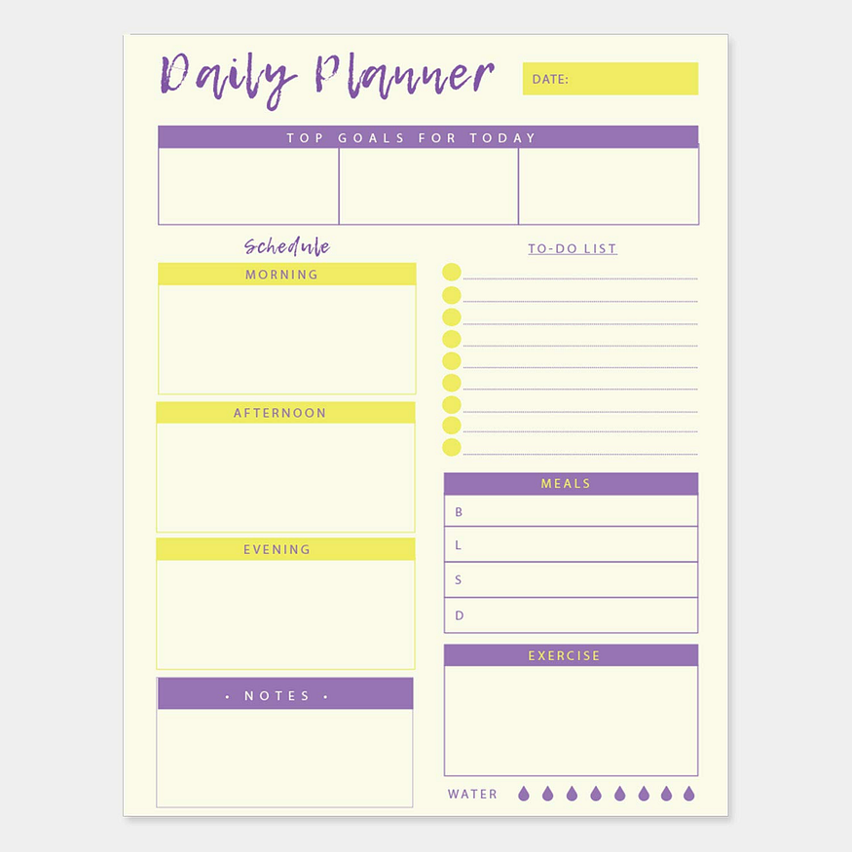
Credit: Amazon.in
Also you can set the goals everyday in order to fulfill the task easily and effectively. Also this will be helping you to understand the demand that the work would be making.
Task prioritization apps
This is one of the important apps that can be used to prioritize the work. Personally I use the apple calendar app that helps me to remember on completing my task based on the effectiveness.
Using the apps will help you to stay up to date with the work and help you to be more effective on completing the work.
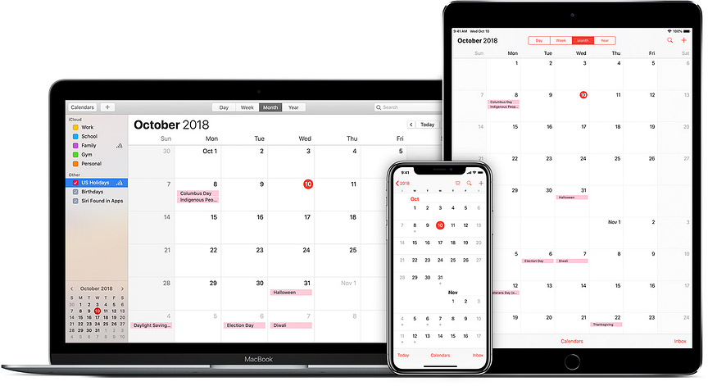
Credit: Apple Support
The notifications from these apps will let you know about the next task and time that you have to spend on that task.
Balancing work and personal life is a part of it
It is important to make sure that there is a good balance in your life and work life. Having balance on both sides will help you think more clearly at the workplace.
You will know how to balance your work and have some extra time for you to spend for yourself.
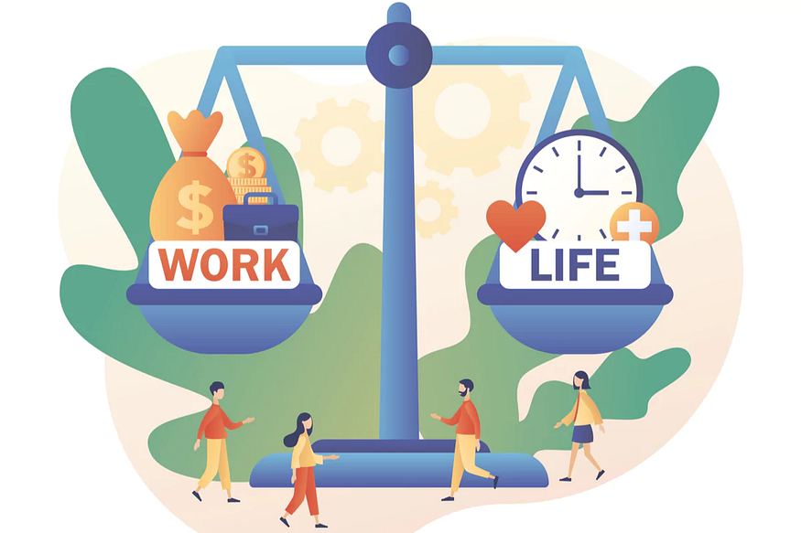
Credit: Team building hub
To-do list optimization
This is important for your brain to know that the work that you are going to start will be of less load than the previous one. So if you make a long to-do list then your brain would be quite tired to think about the work.
This will make you more lazy. So instead of making a long to do list, cut the list short and write the things efficiently. This will help you to stay calm.
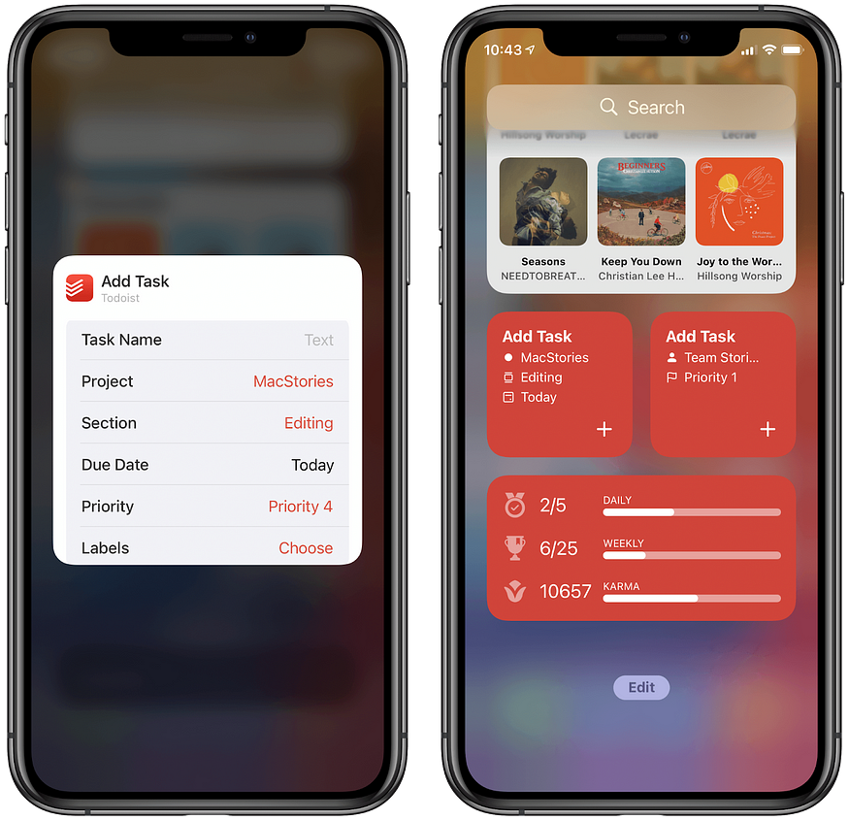
Credit: MacStories
Finally at the end i can say that it is important for us to arrange our work in this busy world. If you want free time then it is important to arrange your work and understand the importance of every work that you have on hand.
This will keep your everyday life smooth like butter.

